**Curriculum Vitae (CV)** 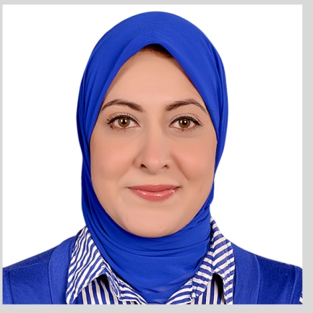

***Personal Information***

**Surname (Family name):** Mhmoud.

**First/Other names:** Amal Mohammedhosni Alameldin mhmoud.

**Title:** Dr.

**Gender:** Female.

**Address:**  El zhraa, takseem eltrabishy ,sherkat feryal , borg badary ,Assiut, Egypt.

##### Nationality: Egyptian.

**Place and date of Birth:**  Libya, 12-10-1983.

**Emails:** [amal.alameldin@yahoo.com](mailto:amal.alameldin@yahoo.com) .

[Amal.alameldin@aun.edu.eg](mailto:Amal.alameldin@aun.edu.eg)

**Telephones:** 01026122444(Mobile).

***Language skills***

Arabic: Native language.

English: Good knowledge (TOEFL).

***Computer Skills:***

ICDL Certified.

***Education***

**2000 - 2006:**  M.B.B.Ch (Bachelor of Medicine and Surgery), Faculty of Medicine, Assiut University, Assiut, Egypt (Degree: very good with honor).

**2007 - 2008:** Training year in the clinical departments of Assiut University Hospital.

**2008 - 2011:** M.Sc. (Master in clinical pathology), Faculty of Medicine, Assiut University, Assiut, Egypt (Degree: very good).

**2012 - 2018:** MD (clinical pathology), Faculty of Medicine, Assiut University, Assiut, Egypt.

***Employment History***

**2007 - 2008:** Training Physician at Assiut university hospitals**,** Faculty of Medicine, AssiutUniversity**.**

**2008 - 2011:**  Resident Physician at Clinical pathology department, Faculty of Medicine, Assiut University**.**

**2011 - 2012:** Assistant Lecturer, Clinical pathology department, Faculty of Medicine, South ValleyUniversity, Qena, Egypt.

**2012 - 2018:** Assistant Lecturer, Clinical pathology department, Faculty of Medicine, Assiut University, Egypt.

**Now** Lecturer, Clinical pathology department, Faculty of Medicine, Assiut University, Egypt

2017 -2019 Doctor at heamatology unit in el-borg lab

2019 doctor at microbiology unit in alfa lab

***Training and workshops***

-International publication of research from 3-5 May 2014.

-Quality standards in teaching from 14-15 June 2014.

-Research team management from 23-24 December 2013.

-Effective presentation from 22-24 March 2014.

-Time and conference management from 10-11 January 2015.

-Statistical analysis using SPSS 26 January 2013.

-Advanced PowerPoint from 21-24 January 2012.

-6th Annual scientific conference of clinical pathology department 5-7 March 2014.

-5th Alexandria clinical pathology department 3-5 March 2015.

-Iso 15189 in clinical chemistry lab 27 October 2013 south Egypt cancer institute Assiut.

-Teaching methods 19-20 December 2015.

-Methods of assessment 26-27 December 2015.

-New practical application of 8 color flow cytometry 11-12 February 2014 South Egypt cancer institute, Assiut University.

-Total quality management in clinical laboratories 25 November 2015.

-Difficulties and risk management of quality in medical lab 15-16 February 2012.

- 7th Annual scientific conference of clinical pathology department Hurghada 25-28 February 2015.

- 4th Annual conference of clinical pathology department 17-18 February 2009 Assiut University.

-BLS provider 11 June 2017.

-10th Annual scientific conference of clinical pathology department Hurghada 21-24 February 2018.

-Acute abdomen scientific meeting of faculty of medicine 26 December 2015.

-Random review of AUHs mortalities in hot areas a start for correction plane scientific meeting of faculty of medicine 23 January 2016.

-Quality assurance system in clinical microbiology laboratories 17-18 September 2017.

-Workshop on microbiology laboratory techniques for surveillance of healthcare associated infections and antimicrobial resistance 15-17 August 2016.

- 7th Annual scientific conference of clinical pathology department, Assiut University 25-28 February 2015.

- 8th Annual scientific conference of clinical pathology department, Assiut University 16-19 March 2016.

-Implementation of electronic surveillance of healthcare associated infections in intensive care units 19-22 March 2017.

-Implementation of electronic surveillance of surgical site infections in hospitals 23 March 2017.

-28th Annual conference of the Egyptian society of laboratory medicine 8-10 April 2017.

-Workshop of stool preparation and examination 28-30 March 2017.

-7th Alexandria clinical pathology department 7-9 March 2017.

-Workshop on total quality management in clinical laboratories 25 November 2015.

-AUC Specialized certificate in infection control 2018.

- 8th Annual conference of clinical pathology department faculty of medicine ,cairo university 17 march 2018 .

- Workshop on challenges in accreditation of microbiology laboratory on 19-march ,2018

Fellows program in international infection control in school of medicine Louisville USA in 2nd November 2018 .

***Publications:***

(Different methods in diagnosis of pulmonary and extrapulmonary tuberculosis) in medical journal of Cairo University 20-12-2017.

(Circulating miRNA-21 and miRNA-23a expression signature as potential biomarkers for early detection of non-small-cell lung cancer) in MicroRNA